**Continuous Random Variables**

Continuous Random Variables may assume any value on the interval in the real number line or in a collection of intervals.

Since any interval contain an infinite number of values, it is not possible to talk about the probability that the random variable will assume a specific value.

Instead, we must think in terms of the probability that a continuous random variable will assume a value within a given **interval.**

(*For example what is the probability of a student being between 1.8 metres and 1.9 metres* )

For a continuous random variable, the ***probability density function (p.d.f.)*** provides the value of the function at any particular value of x.

Two well known continuous probability distributions are

1. The Exponential Distribution
2. The Continuous Uniform Distribution

**The Exponential Distribution**

A continuous probability distribution that in describing the time it takes to complete a task is the exponential probability distribution.

The exponential probability distribution can be used to describe such things as times between arrivals at a carwash, the distance between major defects in a motorway, or the lifetimes of components.

The exponential p.d.f.  is given by

f(x)  = \lambda e ^{-\lambda x}

where \lambda = 1/ \mu , and where \mu  ("mu") is the expected value.

P(X \leq x_o) = 1- e^{-x_o/ \mu}

P(X \geq x_o) = e^{-x_o/ \mu} 

[Note role of the complement]

**Exponential Distribution - Example**

The average lifetime of a mobile phone is 3 years. Product lifetimes often follow an exponential probability distribution.

Assume that this is the case for the lifetimes of a mobile phone.

In this case the expected value is 3 years. \mu = 3

What is the probability that the lifetime will not exceed 2 years?

P(X \leq 2) = 1- e^{-2/ 3}

 = 1- 0.5134

= **0.4866**

**Another Example**

What is the probability that the lifetime of the phone will be at least 3 years?

P(X \geq 3) = e^{-3/ 3} = e^{-1} = 0.3679

What is the probability that the life time will be between 2 years and 5 years?

P(2 \leq X \leq 5) = P(X \geq 2) - P(X \geq 5) 

P(2 \leq X \leq 5)  =  e^{-2/ 3}  - e^{-5/ 3} = 0.5134 - 0.1888 = 0.3246

**The Uniform Distribution**

A uniform distribution is a probability distribution in which every value of the random variable is equally likely. The Probability distribution is given by

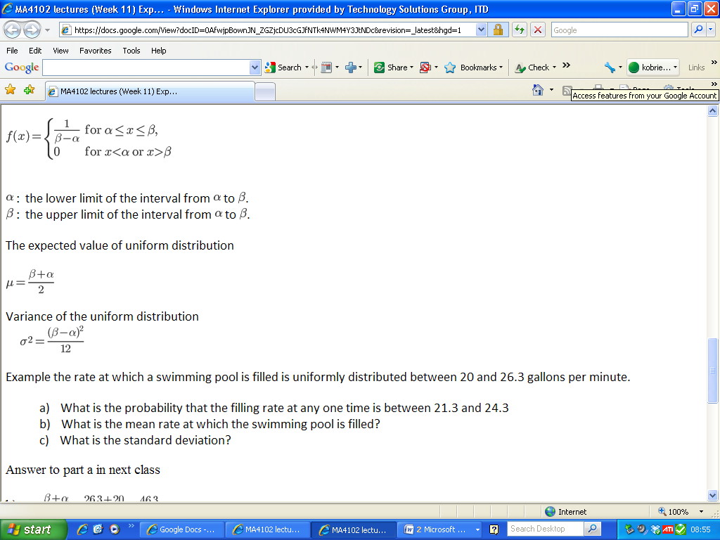

The expected value of uniform distribution

\mu = {\beta + \alpha \over 2}

Variance of the uniform distribution

\sigma^2 = {(\beta - \alpha)^2 \over 12}

Example the rate at which a swimming pool is filled is uniformly distributed between 20 and 26.3 gallons per minute.

a)   What is the probability that the filling rate at any one time is between 21.3 and 24.3

b)   What is the mean rate at which the swimming pool is filled?

c)   What is the standard deviation?

Answer to part a in next class

b) \mu = {\beta + \alpha \over 2} =  {26.3 + 20 \over 2} = {46.3\over 2} =23.15

    23.15 gallons per minute

c) Variance   \sigma^2 = {(\beta - \alpha)^2 \over 12}  = {(6.3)^2 \over 12} = {39.69\over 12} = 3.3075

Standard deviation is the square root of the variance

\sigma = \sqrt{3.3075} =  1.818

1.818 gallons per minute